Basic Economic terms for CRCT Prep

capital goods- Goods, such as machinery, used in the production of commodities; producer goods.

Command economy
When a GOVERNMENT controls all aspects of economic activity
embargo- : an order of a government prohibiting the departure of commercial ships from its ports. Stopping of all trade.

Entrepreneur
The life and soul of the capitalist party. Somebody who has the idea and ENTERPRISE to mix together the other FACTORS OF PRODUCTION to produce something valuable. An entrepreneur must be willing to take a RISK in pursuit of a PROFIT.

Exchange rate
The PRICE at which one currency can be converted into another.
EXPORT: The sale of goods to a foreign country.

Gdp
Gross domestic product, a measure of economic activity in a country. It is calculated by adding the total value of a country's annual output of goods and services.

Human capital
The stuff that enables people to earn a living. Human capital can be increased by investing in education, training and health care.
IMPORT: Goods and services produced by the foreign sector and purchased by the domestic economy.
MARKET-BASED ECONOMY: A mixed economy that relies heavily on markets to answer the three basic questions of allocation, but with a modest amount of government involvement. While it is commonly termed capitalism, market-oriented economy is much more descriptive of how the economy is structure.

Mixed economy
A market economy in which both private-sector FIRMS and firms owned by GOVERNMENT take part in economic activity. The proportions of public and private enterprise in the mix vary a great deal among countries.

OPPORTUNITY COST: The highest valued alternative foregone in the pursuit of an activity. This is a hallmark of anything dealing with economics--and life for that matter--because any action that you take prevents you from doing something else.
PRODUCTION COST: The opportunity cost of using labor, capital, land, and entrepreneurship in the production of goods and services.

Quota
A form of PROTECTIONISM. A country imposes limits on the number of goods that can be imported from another country.

Supply
One of the two words economists use most, along with DEMAND. These are the twin driving forces of the market economy. Supply is the amount of a good or service available at any particular PRICE. The law of supply is that, other things remaining the same, the quantity supplied will increase as the price increases. The actual amount supplied will be determined, ultimately, by what the market price is, which depends on the amount demanded as well as what suppliers are willing to produce.

Tariff
Often used to describe a tax on goods produced abroad imposed by the GOVERNMENT of the country to which they are exported. Many countries have reduced such tariffs as part of the process of freeing up world trade.
TRADE BARRIERS: Restrictions, invariably by government, that prevent free trade among countries. The more popular trade restrictions are tariffs, import quotas, and assorted nontariff barriers. An occasional embargo will be even thrown into this mix. The primary use of trade barriers is to restrict imports from entering in country. By restring imports, domestic producers of the restricted goods are protected from competition and are even subsidized through higher prices. Consumers, though, get the short end of this stick with higher prices and a limited choice of goods. In that producers tend to have more political clout than consumers, it's pretty obvious why trade barriers are a "natural" state of affairs.

Economies of country’s we’ve studied
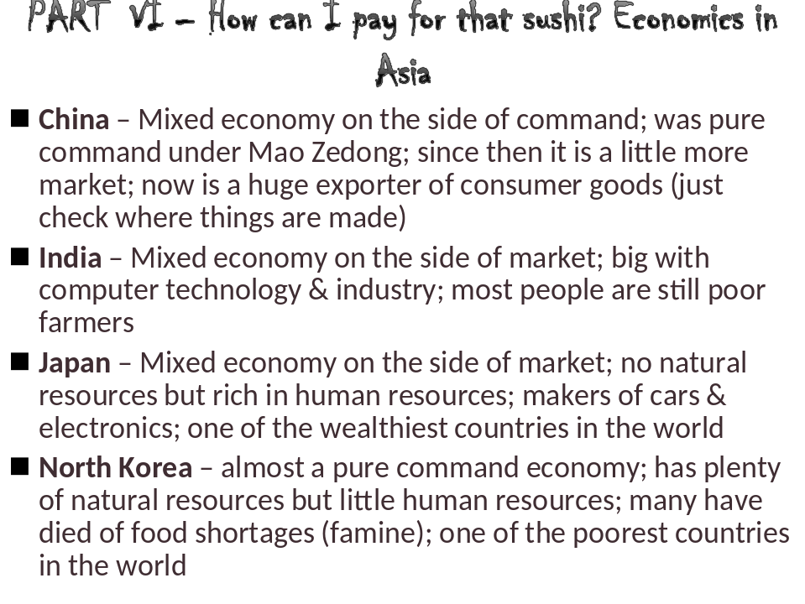

Israel has a mixed economy that is also technologically advanced
Saudi Arabia also has a mixed economy but leans toward government control
Iran has great oil wealth, like Saudi Arabia, through there is also a more mixed economy that has grown in spite of government attempts to keep tighter control
Iran’s command economy has not been very efficient in recent years

The government of Turkey controls the country’s economy.
Turkey’s economy, however, is not entirely a command economy.
A large part of the country’s economy is based on farming.

South Africa is the most developed country in Africa
They have a mixed economy that leans heavily on the market side--currency is called the Rand.
Egypt has a mixed economy, but the state or public owned businesses account for nearly 70% of Egypt's goods or services- making it more of a command econ.

